All Fun & More Play : A Brief Overview
Playing is all fun and games except it also has a certain amount of qualities which helps a kid grow up. They learn to play and that itself is the first step for them to start learning. While learning to play is easily adaptable, staying focused isn't. Kids are likely to get distracted than any average adult. Kid Amusement here is very necessary since it adds to their positive growth. For parents to nurture their kids playfully, they can look out for the Best kids play area‌ or Kids Activity Area‌, where they'll be able to interact and socialize with other kids as well.
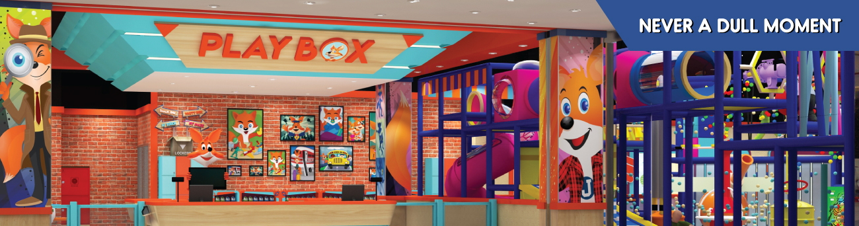
Apart from the obvious benefits, let's dive deeper into the benefits:
- Outdoor activities have a profound effect on kids but with today's availability of mobile and other devices, they are likely to stay indoors. But, parents must convince their kids to engage in some play activity as they are good for their muscle growth, bone density and lung functionality. There are countless indoor playgrounds equipped with the best technologies where the kids can get a flavor of indoor playfulness with outdoor activities. Playing is inherently necessary for kids to grow and be healthy.
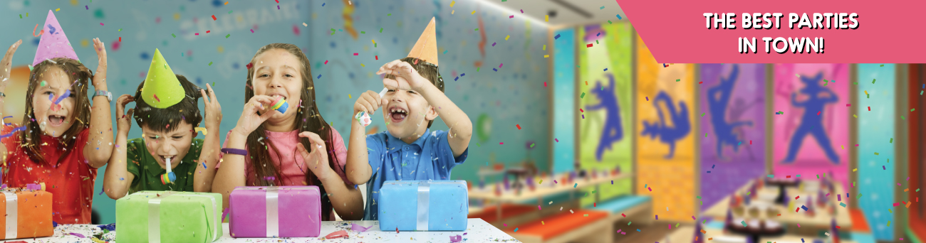
- The physical benefits of any play are very much evident but what about emotional development? Kids while playing can discover the various layers of emotions that they are developing. Be it anger or frustration, they'll be experiencing all these emotions while building self-esteem and self-confidence. Even when they are at a Kids Birthday party‌, they are likely to receive emotions that they can't comprehend but soon will, with their experience to deal with it.
- Playgrounds can offer Kids Soft Play‌ ‌which gives them a sense of accomplishment and that is something rewarding for most kids. Once they are acquainted with the obstacles, they will also grow confident about getting across them.
- Free play is often quite therapeutic for kids as it helps them to release any emotion that they are having. And they should also be advised not to suppress any trauma as that may hinder their emotional development.
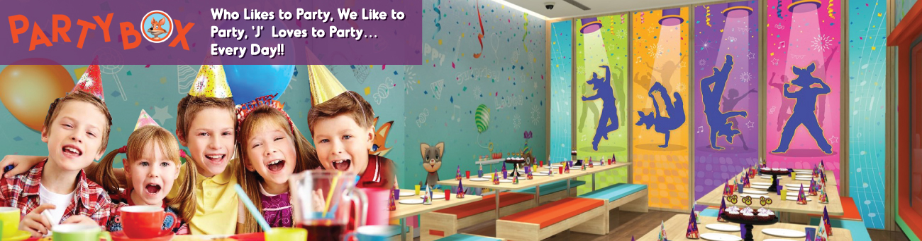
So go ahead and arrange for some cool gaming zones for your kids next birthday!

